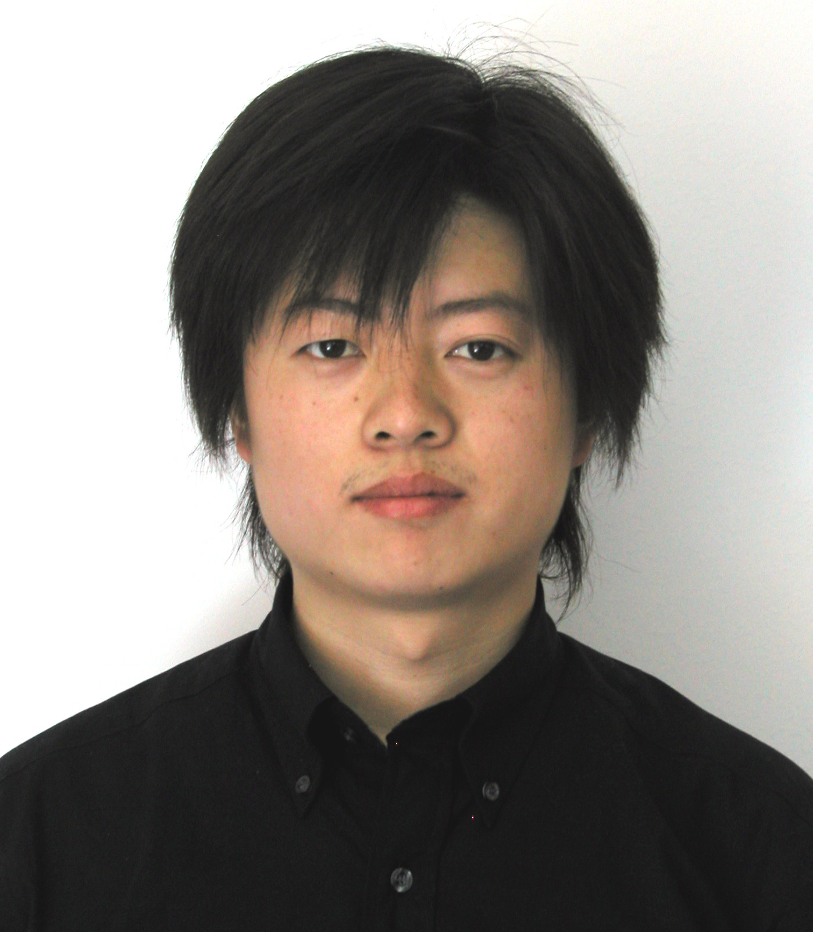
Haifeng Lu
Birth: 1979.01.16
Tel: +86-10-88579103(Home)
+86-13671330927(Mobile)
Address: Weigongcun Subdistrict 19#311 , Haidian, Beijing 100081

Email & MSN: machael_lvhf@hotmail.com
Profile Summary
A highly motivated professional with verifiable record of accomplishment, rich engineering and management experience and solid body of systemized knowledge. Highly innovative, recognized as a solution-focused and result –oriented individual. Areas of strength include:
• Capability to achieve success in adversity • Passion for technology and innovation
• Effective leadership and team-building skills • Fast learning capability
• Agility under pressure • Quantitive problem-analyzing abilities
• Highly mathematical modeling and programming talent • Solid English communication and people skills
Education
- Tsinghua University Master, Electrical Engineering Department 2000-2003
Thesis: <Research on the Real-Time Channel Estimation in Low Voltage Power Line Communications Based on OFDM>, which is a base subject research project sponsored by National Nature Science Foundation. The Tsinghua University 2003 “Excellent Master Thesis” Award Winner.
- Tsinghua University Bachelor, Electrical Engineering Department 1996-2000
Tsinghua Univ. is the most prestigious university of engineering and technology in China. My score in the College Entrance Examination was 656, the 12th highest score among more than one hundred thousand examinees in Jilin province in 1996.
Career Experience
- Fuxing-Xiaocheng Co.Ltd, Beijing IC Design House 2003-Present
Vice Manager of ASIC Dept., Project Manager, System Architecture Designer, Chief Algorithm Engineer, work duty includes:
- Directing the new ASIC project, charged with the specification definition, function defin
- Architecture design, algorithm research, behavior-level simulation;
- Essential RTL module coding;
- Development supervising, coordinating work progress of digital and analog engineers;
- Worked with ASIC department and led the digital and analog engineers, charged with algorithm and system architecture design and project management.
- User manual writing, revising, publishing;
- Assisted marketing and sales presentations;
Project Experience Accomplishments
- PL2200 SOC Project Manager 10/2005-06/2007
PL2200 is a power line communications application specific SOC, which contained an enhanced Intel 8052 micro-processor and a power line communication PHY transceiver. BPSK modulation, carrier freq is 131.5kHz, 5.5kbps, compatible with EIA709.2 standard.
Designed the system architecture, all-digital receiver front-end, innovative band-pass sampling algorithm, greatly reducing the need for complexity and scale of digital filter, simulated the system processing procedure and adjusted the key parameters in Matlab, Verilog coding task assignment, testbench by Modelsim simulation, digital prototype verification by Altera FPGA.
- PL3223 Project Manager 01/2005-10/2005
PL3223 is a three-phase electrical energy measurement application specific IC, compliant with IEC678/61036, GB/T 17215, with very high active energy measurement accuracy(<0.1%) and high reactive energy measurement accuracy(<0.5%), which contains 6 delta-segma ADC and rich peripheral measurement function circuits.
Designed the system architecture, active measurement and reactive energy measurement algorithm based on Hilbert filterer. System processing and digital filter coefficients is designed in Matlab simulation and prototype is verified using Altera FPGA。
- PL3201 Algorithm Engineer 07/2003-12/2004
PL3201 is a multi-function energy meter SOC which contains an enhanced 8052 MCU and high accuracy energy measurement unit, and integrates rich function circuits such as PLC Unit, ADC, LCD Control, Motor Pulse Generator, System Power Monitor and so on.
Designed the innovative CDMA power line communication system, QPSK modulation and demodulation, power measurement algorithm.
Computer Skills
Matlab, Simulink, Verilog, Visual C++, Keil C51, Visual Basic, Python, Java
Modelsim, QuartusII, Synopsys Design Compiler
Word, Visio, Photoshop, SmartDraw, AutoIt, Latex2e
Publications, Honors and Activities
- <Power Line Communications – Challenges and Solutions>Presentation on the fifteenth International Electrical Metering Development Forum, Changsha November 2007
- <The Characteristics of Low Voltage Power Line Channels and Strategy>Presentation in the thirteenth International Electrical Metering Development Forum, Beijing November 2006
- <Research on the Real-Time Channel Estimation in Low Voltage Power Line Communications Based on OFDM> (Awarded the “Excellent Master Thesis” in Tsinghua University 2003)
- <Real-time Channel Estimation of Power Line OFDM Communications> AUTOMATION OF ELECTRIC POWER SYSTEMS 2003 Vol.27 No.9 P.29-31,36
Personal Hobbies
Photography, Trekking, Ski, Drama, Music.

